

**Министерство науки и высшего образования**

**Российской Федерации**

**федеральное государственное бюджетное образовательное учреждение**

**высшего образования**

**«Московский государственный технологический университет «СТАНКИН»**

**(ФГБОУ ВО «МГТУ «СТАНКИН»)**

Институт цифровых интеллектуальных систем

Дисциплина: «Программирование обработки сложных поверхностей на

станках ЧПУ»

Отчет по лабораторной работе №4

«Генерация и редактирование текстовых контуров. Обработка нескольких поверхностей заготовки»

Выполнил:

студент группы АДМ-21-05 __________ Абдулзагиров М.М.

(подпись) (ФИО)

Принял

преподаватель: __________ _Мартинов Г.М._

(подпись) (ФИО)

Дата:_________

Москва 2022

**Цель работы:** Генерация текстовых контуров и их использование на различных гранях заготовки.

**Ход работы**

С помощью утилиты «Текст в G-код» были сгенерированы траектории для создания 3-х надписей на заготовке.

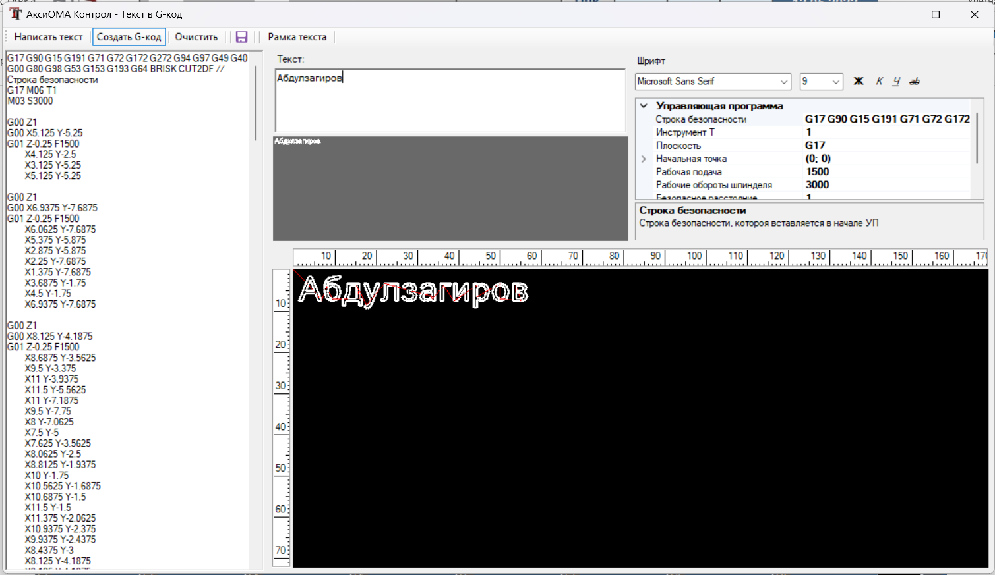

Рис.1. Окно утилиты «Текст в G-код».

В коде программы с помощью команды workpiece был задан начальный размер куба и начала координат

#workpiece(0, 1024, 1, 80, 80, 80, -15, -33, -80)

И после обрисовки первой и второй надписи были добавлены комаманды workpiece_pos для изменения положения и ориентации заготовки

#workpiece_pos(-15, -33, 0, 0, 90, 0)

…

#workpiece_pos(-5, -40, -80, 0, 90, 90)

В результате был получен куб 3-мя надписями (рис. 2)

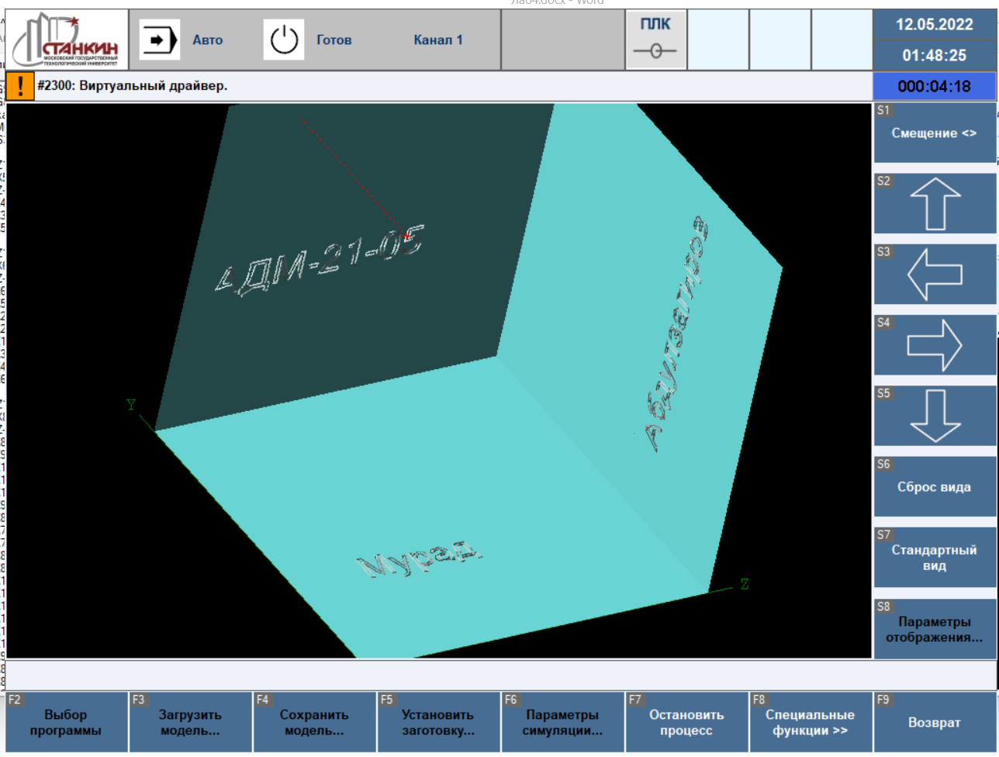

Рис.2. Исходный вид заготовки

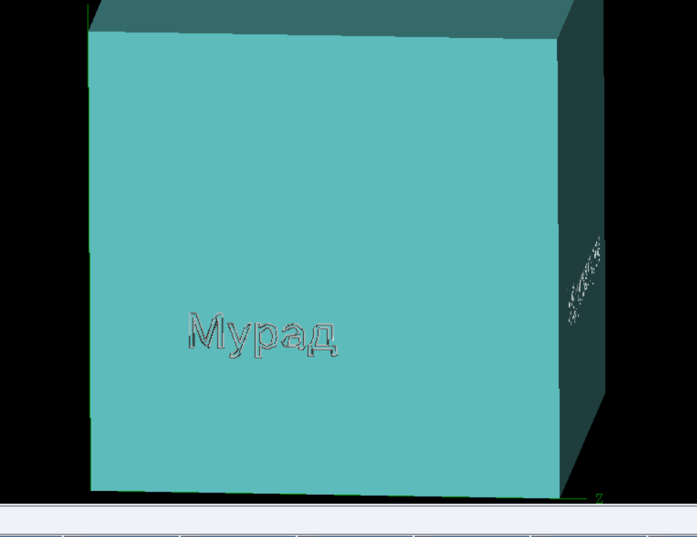

Рис.3. Исходный вид заготовки



Рис.3. Исходный вид заготовки.

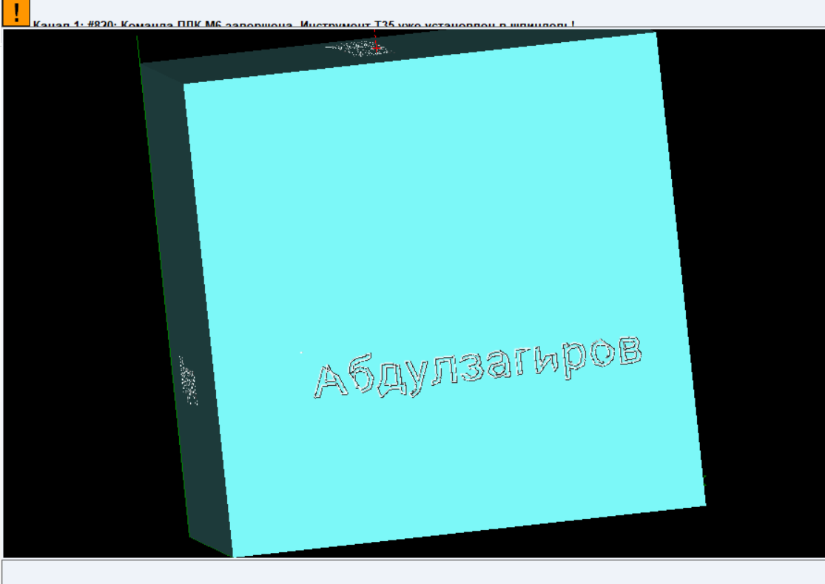

Рис.4. Исходный вид заготовки (один из вариантов).

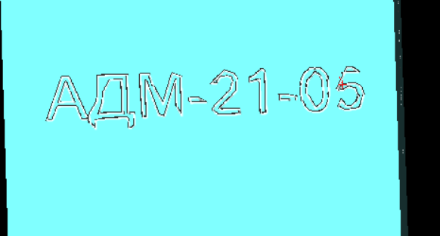

Рис.5. Исходный вид заготовки.

(При каждом запуске программы отображаемый контур всегда получался разным, возможно особенность «железа» компьютера (процессор AMD))

Листинг 1.

G17 G90 G15 G191 G71 G72 G172 G272 G94 G97 G49 G40 G00 G80 G98 G53 G153 G193 G64 BRISK CUT2DF // Строка безопасности

#workpiece(0, 1024, 1, 80, 80, 80, -15, -33, -80)

G17 M06 T35

M03 S300

G00 Z1

G00 X5.125 Y-5.25

G01 Z-0.25 F1500

X4.125 Y-2.5

X3.125 Y-5.25

X5.125 Y-5.25

G00 Z1

G00 X6.9375 Y-7.6875

G01 Z-0.25 F1500

X6.0625 Y-7.6875

X5.375 Y-5.875

X2.875 Y-5.875

X2.25 Y-7.6875

X1.375 Y-7.6875

X3.6875 Y-1.75

X4.5 Y-1.75

X6.9375 Y-7.6875

G00 Z1

G00 X8.125 Y-4.1875

G01 Z-0.25 F1500

X8.6875 Y-3.5625

X9.5 Y-3.375

X11 Y-3.9375

X11.5 Y-5.5625

X11 Y-7.1875

X9.5 Y-7.75

X8 Y-7.0625

X7.5 Y-5

X7.625 Y-3.5625

X8.0625 Y-2.5

X8.8125 Y-1.9375

X10 Y-1.75

X10.5625 Y-1.6875

X10.6875 Y-1.5

X11.5 Y-1.5

X11.375 Y-2.0625

X10.9375 Y-2.375

X9.9375 Y-2.4375

X8.4375 Y-3

X8.125 Y-4.1875

X8.125 Y-4.1875

G00 Z1

G00 X9.5 Y-7.1875

G01 Z-0.25 F1500

X10.375 Y-6.75

X10.75 Y-5.5625

X10.375 Y-4.375

X9.5 Y-4

X8.625 Y-4.375

X8.3125 Y-5.5625

X8.625 Y-6.75

X9.5 Y-7.1875

X9.5 Y-7.1875

G00 Z1

G00 X16.125 Y-7.0625

G01 Z-0.25 F1500

X16.75 Y-7.0625

X16.75 Y-8.8125

X16 Y-8.8125

X16 Y-7.6875

X12.75 Y-7.6875

X12.75 Y-8.8125

X12 Y-8.8125

X12 Y-7.0625

X12.375 Y-7.0625

X12.9375 Y-5.6875

X13.125 Y-3.5625

X13.125 Y-3.375

X16.125 Y-3.375

X16.125 Y-7.0625

G00 Z1

G00 X15.375 Y-4

G01 Z-0.25 F1500

X13.875 Y-4

X13.6875 Y-5.8125

X13.25 Y-7.0625

X15.375 Y-7.0625

X15.375 Y-4

G00 Z1

G00 X17.8125 Y-8.6875

G01 Z-0.25 F1500

X18.3125 Y-8.4375

X18.75 Y-7.6875

X17.875 Y-5.4375

X17.125 Y-3.375

X17.9375 Y-3.375

X18.625 Y-5.375

X19.0625 Y-6.75

X20.1875 Y-3.375

X21 Y-3.375

X19.375 Y-7.6875

X19 Y-8.625

X18.5625 Y-9.1875

X17.9375 Y-9.4375

X17.4375 Y-9.375

X17.4375 Y-8.6875

X17.8125 Y-8.6875

X17.8125 Y-8.6875

G00 Z1

G00 X22.1875 Y-3.375

G01 Z-0.25 F1500

X25.4375 Y-3.375

X25.4375 Y-7.6875

X24.6875 Y-7.6875

X24.6875 Y-4

X22.9375 Y-4

X22.9375 Y-6.25

X22.625 Y-7.4375

X21.8125 Y-7.6875

X21.3125 Y-7.6875

X21.3125 Y-7.0625

X21.75 Y-7.125

X22.0625 Y-6.9375

X22.1875 Y-6.25

X22.1875 Y-3.375

G00 Z1

G00 X29.1875 Y-5.4375

G01 Z-0.25 F1500

X29.8125 Y-5.875

X30 Y-6.5

X29.5 Y-7.4375

X28.125 Y-7.75

X26.8125 Y-7.4375

X26.3125 Y-6.5625

X27.0625 Y-6.5625

X27.375 Y-7

X28.125 Y-7.1875

X28.9375 Y-7

X29.1875 Y-6.5

X29.0625 Y-6.0625

X28.6875 Y-5.8125

X28 Y-5.75

X27.75 Y-5.75

X27.75 Y-5.1875

X28 Y-5.1875

X28.875 Y-5

X29.125 Y-4.5625

X28.875 Y-4.0625

X28.1875 Y-3.875

X27.5 Y-4

X27.25 Y-4.375

X26.4375 Y-4.375

X26.9375 Y-3.5625

X28.125 Y-3.3125

X29.4375 Y-3.625

X29.875 Y-4.5

X29.75 Y-5.0625

X29.1875 Y-5.4375

X29.1875 Y-5.4375

G00 Z1

G00 X33.6875 Y-6.5625

G01 Z-0.25 F1500

X33.6875 Y-5.625

X33.1875 Y-5.625

X31.9375 Y-5.8125

X31.5 Y-6.5

X31.75 Y-7

X32.4375 Y-7.1875

X33.125 Y-7

X33.6875 Y-6.5625

X33.6875 Y-6.5625

G00 Z1

G00 X33.6875 Y-7.25

G01 Z-0.25 F1500

X32.1875 Y-7.75

X31.125 Y-7.4375

X30.75 Y-6.5625

X31.375 Y-5.4375

X33.3125 Y-5.0625

X33.6875 Y-5.0625

X33.625 Y-4.375

X33.375 Y-4

X32.6875 Y-3.875

X31.875 Y-4.0625

X31.625 Y-4.625

X30.875 Y-4.625

X31.375 Y-3.625

X32.6875 Y-3.3125

X34 Y-3.625

X34.4375 Y-4.875

X34.4375 Y-7.6875

X33.6875 Y-7.6875

X33.6875 Y-7.25

G00 Z1

G00 X36.5 Y-4

G01 Z-0.25 F1500

X36.5 Y-7.6875

X35.75 Y-7.6875

X35.75 Y-3.375

X38.25 Y-3.375

X38.25 Y-4

X36.5 Y-4

G00 Z1

G00 X39 Y-7.6875

G01 Z-0.25 F1500

X39 Y-3.375

X39.75 Y-3.375

X39.75 Y-6.625

X41.6875 Y-3.375

X42.5 Y-3.375

X42.5 Y-7.6875

X41.75 Y-7.6875

X41.75 Y-4.4375

X39.8125 Y-7.6875

X39 Y-7.6875

G00 Z1

G00 X44.5625 Y-3.875

G01 Z-0.25 F1500

X45.75 Y-3.3125

X47.0625 Y-3.875

X47.5625 Y-5.5

X47 Y-7.1875

X45.75 Y-7.75

X44.5625 Y-7.375

X44.5625 Y-9.3125

X43.8125 Y-9.3125

X43.8125 Y-3.375

X44.5625 Y-3.375

X44.5625 Y-3.875

G00 Z1

G00 X44.5625 Y-6.6875

G01 Z-0.25 F1500

X45.6875 Y-7.1875

X46.4375 Y-6.75

X46.75 Y-5.5

X46.5 Y-4.3125

X45.6875 Y-3.875

X44.5625 Y-4.625

X44.5625 Y-6.6875

G00 Z1

G00 X50.25 Y-3.3125

G01 Z-0.25 F1500

X51.75 Y-3.875

X52.3125 Y-5.5

X51.75 Y-7.1875

X50.25 Y-7.75

X48.8125 Y-7.1875

X48.25 Y-5.5

X48.8125 Y-3.875

X50.25 Y-3.3125

X50.25 Y-3.3125

G00 Z1

G00 X50.25 Y-7.1875

G01 Z-0.25 F1500

X51.1875 Y-6.75

X51.5 Y-5.5

X51.1875 Y-4.3125

X50.25 Y-3.875

X49.375 Y-4.3125

X49.0625 Y-5.5

X49.375 Y-6.75

X50.25 Y-7.1875

X50.25 Y-7.1875

G00 Z1

G00 X55.3125 Y-7.6875

G01 Z-0.25 F1500

X53.3125 Y-7.6875

X53.3125 Y-3.375

X55 Y-3.375

X56.1875 Y-3.6875

X56.625 Y-4.5

X56.0625 Y-5.4375

X56.8125 Y-6.5

X56.375 Y-7.375

X55.3125 Y-7.6875

X55.3125 Y-7.6875

G00 Z1

G00 X54.0625 Y-4

G01 Z-0.25 F1500

X54.0625 Y-5.1875

X54.9375 Y-5.1875

X55.625 Y-5.0625

X55.875 Y-4.5625

X55.625 Y-4.125

X54.875 Y-4

X54.0625 Y-4

G00 Z1

G00 X54.0625 Y-5.75

G01 Z-0.25 F1500

X54.0625 Y-7.0625

X55.0625 Y-7.0625

X55.75 Y-6.9375

X56 Y-6.4375

X55.75 Y-5.9375

X55 Y-5.75

G00 X54.0625 Y-5.75

G00 Z1

#workpiece_pos(-15, -33, 0, 0, 90, 0)

G00 Z1

G00 X7.6875 Y-7.6875

G01 Z-0.25 F1500

X6.9375 Y-7.6875

X6.9375 Y-2.625

X5.25 Y-7.6875

X4.5 Y-7.6875

X2.8125 Y-2.625

X2.8125 Y-7.6875

X2.0625 Y-7.6875

X2.0625 Y-1.75

X3.25 Y-1.75

X4.875 Y-6.6875

X6.5 Y-1.75

X7.6875 Y-1.75

X7.6875 Y-7.6875

G00 Z1

G00 X9.3125 Y-8.6875

G01 Z-0.25 F1500

X9.8125 Y-8.4375

X10.25 Y-7.6875

X9.4375 Y-5.4375

X8.625 Y-3.375

X9.4375 Y-3.375

X10.125 Y-5.375

X10.625 Y-6.75

X11.75 Y-3.375

X12.5625 Y-3.375

X10.9375 Y-7.6875

X10.5625 Y-8.625

X10.125 Y-9.1875

X9.4375 Y-9.4375

X9 Y-9.375

X9 Y-8.6875

X9.3125 Y-8.6875

X9.3125 Y-8.6875

G00 Z1

G00 X14.125 Y-3.875

G01 Z-0.25 F1500

X15.375 Y-3.3125

X16.6875 Y-3.875

X17.125 Y-5.5

X16.625 Y-7.1875

X15.3125 Y-7.75

X14.125 Y-7.375

X14.125 Y-9.3125

X13.375 Y-9.3125

X13.375 Y-3.375

X14.125 Y-3.375

X14.125 Y-3.875

G00 Z1

G00 X14.125 Y-6.6875

G01 Z-0.25 F1500

X15.25 Y-7.1875

X16.0625 Y-6.75

X16.3125 Y-5.5

X16.0625 Y-4.3125

X15.3125 Y-3.875

X14.125 Y-4.625

X14.125 Y-6.6875

G00 Z1

G00 X20.8125 Y-6.5625

G01 Z-0.25 F1500

X20.8125 Y-5.625

X20.3125 Y-5.625

X19.0625 Y-5.8125

X18.6875 Y-6.5

X18.875 Y-7

X19.5625 Y-7.1875

X20.3125 Y-7

X20.8125 Y-6.5625

X20.8125 Y-6.5625

G00 Z1

G00 X20.8125 Y-7.25

G01 Z-0.25 F1500

X19.3125 Y-7.75

X18.3125 Y-7.4375

X17.875 Y-6.5625

X18.5 Y-5.4375

X20.4375 Y-5.0625

X20.8125 Y-5.0625

X20.8125 Y-4.375

X20.5 Y-4

X19.8125 Y-3.875

X19 Y-4.0625

X18.75 Y-4.625

X18 Y-4.625

X18.5 Y-3.625

X19.875 Y-3.3125

X21.125 Y-3.625

X21.625 Y-4.875

X21.625 Y-7.6875

X20.8125 Y-7.6875

X20.8125 Y-7.25

G00 Z1

G00 X26.4375 Y-7.0625

G01 Z-0.25 F1500

X27.0625 Y-7.0625

X27.0625 Y-8.8125

X26.3125 Y-8.8125

X26.3125 Y-7.6875

X23.0625 Y-7.6875

X23.0625 Y-8.8125

X22.3125 Y-8.8125

X22.3125 Y-7.0625

X22.6875 Y-7.0625

X23.25 Y-5.6875

X23.4375 Y-3.5625

X23.4375 Y-3.375

X26.4375 Y-3.375

X26.4375 Y-7.0625

G00 Z1

G00 X25.6875 Y-4

G01 Z-0.25 F1500

X24.1875 Y-4

X24 Y-5.8125

X23.5625 Y-7.0625

X25.6875 Y-7.0625

G00 X25.6875 Y-4

G00 Z1

#workpiece_pos(-5, -40, -80, 0, 90, 90)

G00 Z1

G00 X5.6875 Y-5.8125

G01 Z-0.25 F1500

X4.5625 Y-2.75

X3.4375 Y-5.8125

X5.6875 Y-5.8125

G00 Z1

G00 X7.75 Y-8.5

G01 Z-0.25 F1500

X6.75 Y-8.5

X6 Y-6.5

X3.1875 Y-6.5

X2.5 Y-8.5

X1.5625 Y-8.5

X4.0625 Y-1.9375

X5 Y-1.9375

X7.75 Y-8.5

G00 Z1

G00 X14 Y-7.75

G01 Z-0.25 F1500

X14.875 Y-7.75

X14.875 Y-10.0625

X14 Y-10.0625

X14 Y-8.5

X8.9375 Y-8.5

X8.9375 Y-10.0625

X8.0625 Y-10.0625

X8.0625 Y-7.75

X8.625 Y-7.75

X9.25 Y-6.125

X9.375 Y-4.875

X9.4375 Y-3.0625

X9.4375 Y-1.9375

X14 Y-1.9375

X14 Y-7.75

G00 Z1

G00 X13.125 Y-7.75

G01 Z-0.25 F1500

X13.125 Y-2.6875

X10.3125 Y-2.6875

X10.3125 Y-3.125

X10.25 Y-4.8125

X10.125 Y-6.0625

X9.5 Y-7.75

X13.125 Y-7.75

G00 Z1

G00 X22.1875 Y-8.5

G01 Z-0.25 F1500

X21.375 Y-8.5

X21.375 Y-2.9375

X19.5 Y-8.5

X18.6875 Y-8.5

X16.8125 Y-2.9375

X16.8125 Y-8.5

X16 Y-8.5

X16 Y-1.9375

X17.3125 Y-1.9375

X19.0625 Y-7.4375

X20.875 Y-1.9375

X22.1875 Y-1.9375

X22.1875 Y-8.5

G00 Z1

G00 X25.9375 Y-6.5625

G01 Z-0.25 F1500

X23.4375 Y-6.5625

X23.4375 Y-5.75

X25.9375 Y-5.75

X25.9375 Y-6.5625

G00 Z1

G00 X31 Y-8.5

G01 Z-0.25 F1500

X26.625 Y-8.5

X27 Y-7.375

X28.375 Y-6

X29.75 Y-4.75

X30.0625 Y-3.625

X29.75 Y-2.8125

X28.875 Y-2.5

X28.0625 Y-2.8125

X27.625 Y-3.75

X26.75 Y-3.75

X27.4375 Y-2.3125

X28.875 Y-1.8125

X30.4375 Y-2.375

X30.9375 Y-3.6875

X30.5625 Y-4.9375

X30 Y-5.625

X29 Y-6.5

X28.125 Y-7.3125

X27.8125 Y-7.75

X31 Y-7.75

X31 Y-8.5

G00 Z1

G00 X35.0625 Y-8.5

G01 Z-0.25 F1500

X34.1875 Y-8.5

X34.1875 Y-3.3125

X32.625 Y-3.6875

X32.625 Y-3

X33.875 Y-2.6875

X34.4375 Y-1.8125

X35.0625 Y-1.8125

X35.0625 Y-8.5

G00 Z1

G00 X39.6875 Y-6.5625

G01 Z-0.25 F1500

X37.1875 Y-6.5625

X37.1875 Y-5.75

X39.6875 Y-5.75

X39.6875 Y-6.5625

G00 Z1

G00 X42.625 Y-1.8125

G01 Z-0.25 F1500

X43.5625 Y-2

X44.25 Y-2.6875

X44.625 Y-3.75

X44.75 Y-5.25

X44.625 Y-6.75

X44.25 Y-7.8125

X43.5625 Y-8.4375

X42.625 Y-8.625

X41.6875 Y-8.4375

X41 Y-7.8125

X40.5625 Y-6.75

X40.4375 Y-5.25

X40.5625 Y-3.75

X41 Y-2.6875

X41.6875 Y-2

X42.625 Y-1.8125

X42.625 Y-1.8125

G00 Z1

G00 X42.625 Y-8

G01 Z-0.25 F1500

X43.5625 Y-7.375

X43.8125 Y-6.5625

X43.875 Y-5.25

X43.8125 Y-3.9375

X43.5625 Y-3.0625

X42.625 Y-2.5

X41.6875 Y-3.0625

X41.4375 Y-3.9375

X41.3125 Y-5.25

X41.4375 Y-6.5625

X41.6875 Y-7.375

X42.625 Y-8

X42.625 Y-8

G00 Z1

G00 X46.8125 Y-4.5625

G01 Z-0.25 F1500

X48.0625 Y-4.125

X49.5 Y-4.75

X50.0625 Y-6.3125

X49.5 Y-8

X47.8125 Y-8.625

X46.375 Y-8.1875

X45.6875 Y-6.8125

X46.5625 Y-6.8125

X47 Y-7.6875

X47.8125 Y-8

X48.8125 Y-7.5

X49.1875 Y-6.375

X48.8125 Y-5.25

X47.8125 Y-4.875

X46.625 Y-5.4375

X45.9375 Y-5.4375

X46.25 Y-1.9375

X49.75 Y-1.9375

X49.75 Y-2.6875

X46.9375 Y-2.6875

G00 X46.8125 Y-4.5625

G00 Z1

M30

**Вывод:** в данной лабораторной работе мы изучили программные инструменты для создания управляющие программы с использованием генерации текстовых контуров и создали надписи на различных гранях заготовки.